**GUI for LC Software:**

**Procedure for Contour Generation:**

1. The python code for Contour generation when run opens up the GUI as shown in the fig. 1 below.

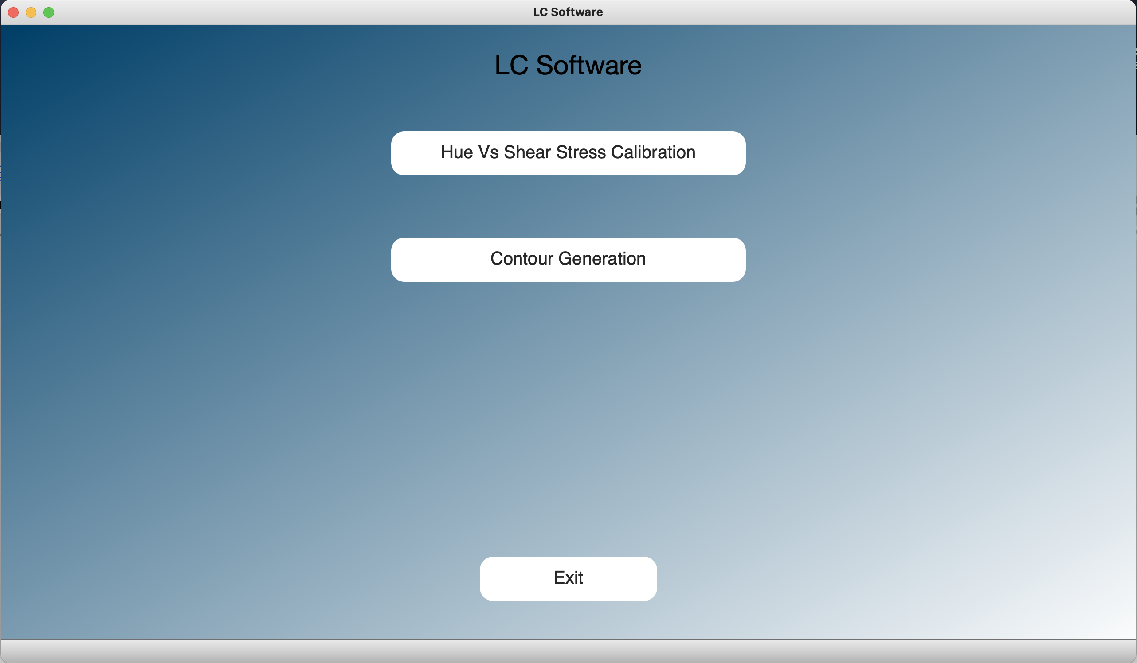

Fig 1. LC Software startup page

1. The various options available in the software are shown in the startup page. There are two options available currently which are Hue vs Shear Stress Calibration for Liquid Crystal and the Contour Generation module for generating the contour plots.
2. The Contour Generation module page shown in fig. 2 consists of various required options for processing image and generating contours. The user can select the image directory, the image to be processed, the final resolution of the contour image, the kernel size for image denoising, closed contour area threshold and the option for which the contour plot needs to be generated (e.g. red, green, blue, hue, shear stress, skin friction, etc.).

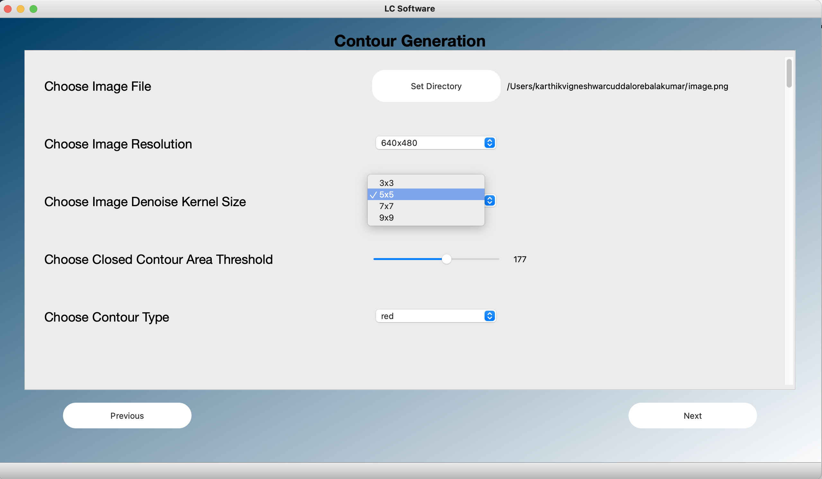

Fig 2. Contour Generation module page

1. The next button opens up the window where the user can select the ROI on the chosen image on which the contour lines have to be plotted.
2. The user options are saved when next button is pressed and the chosen image opens up after getting resized according to the chosen resolution as shown in the fig 3.

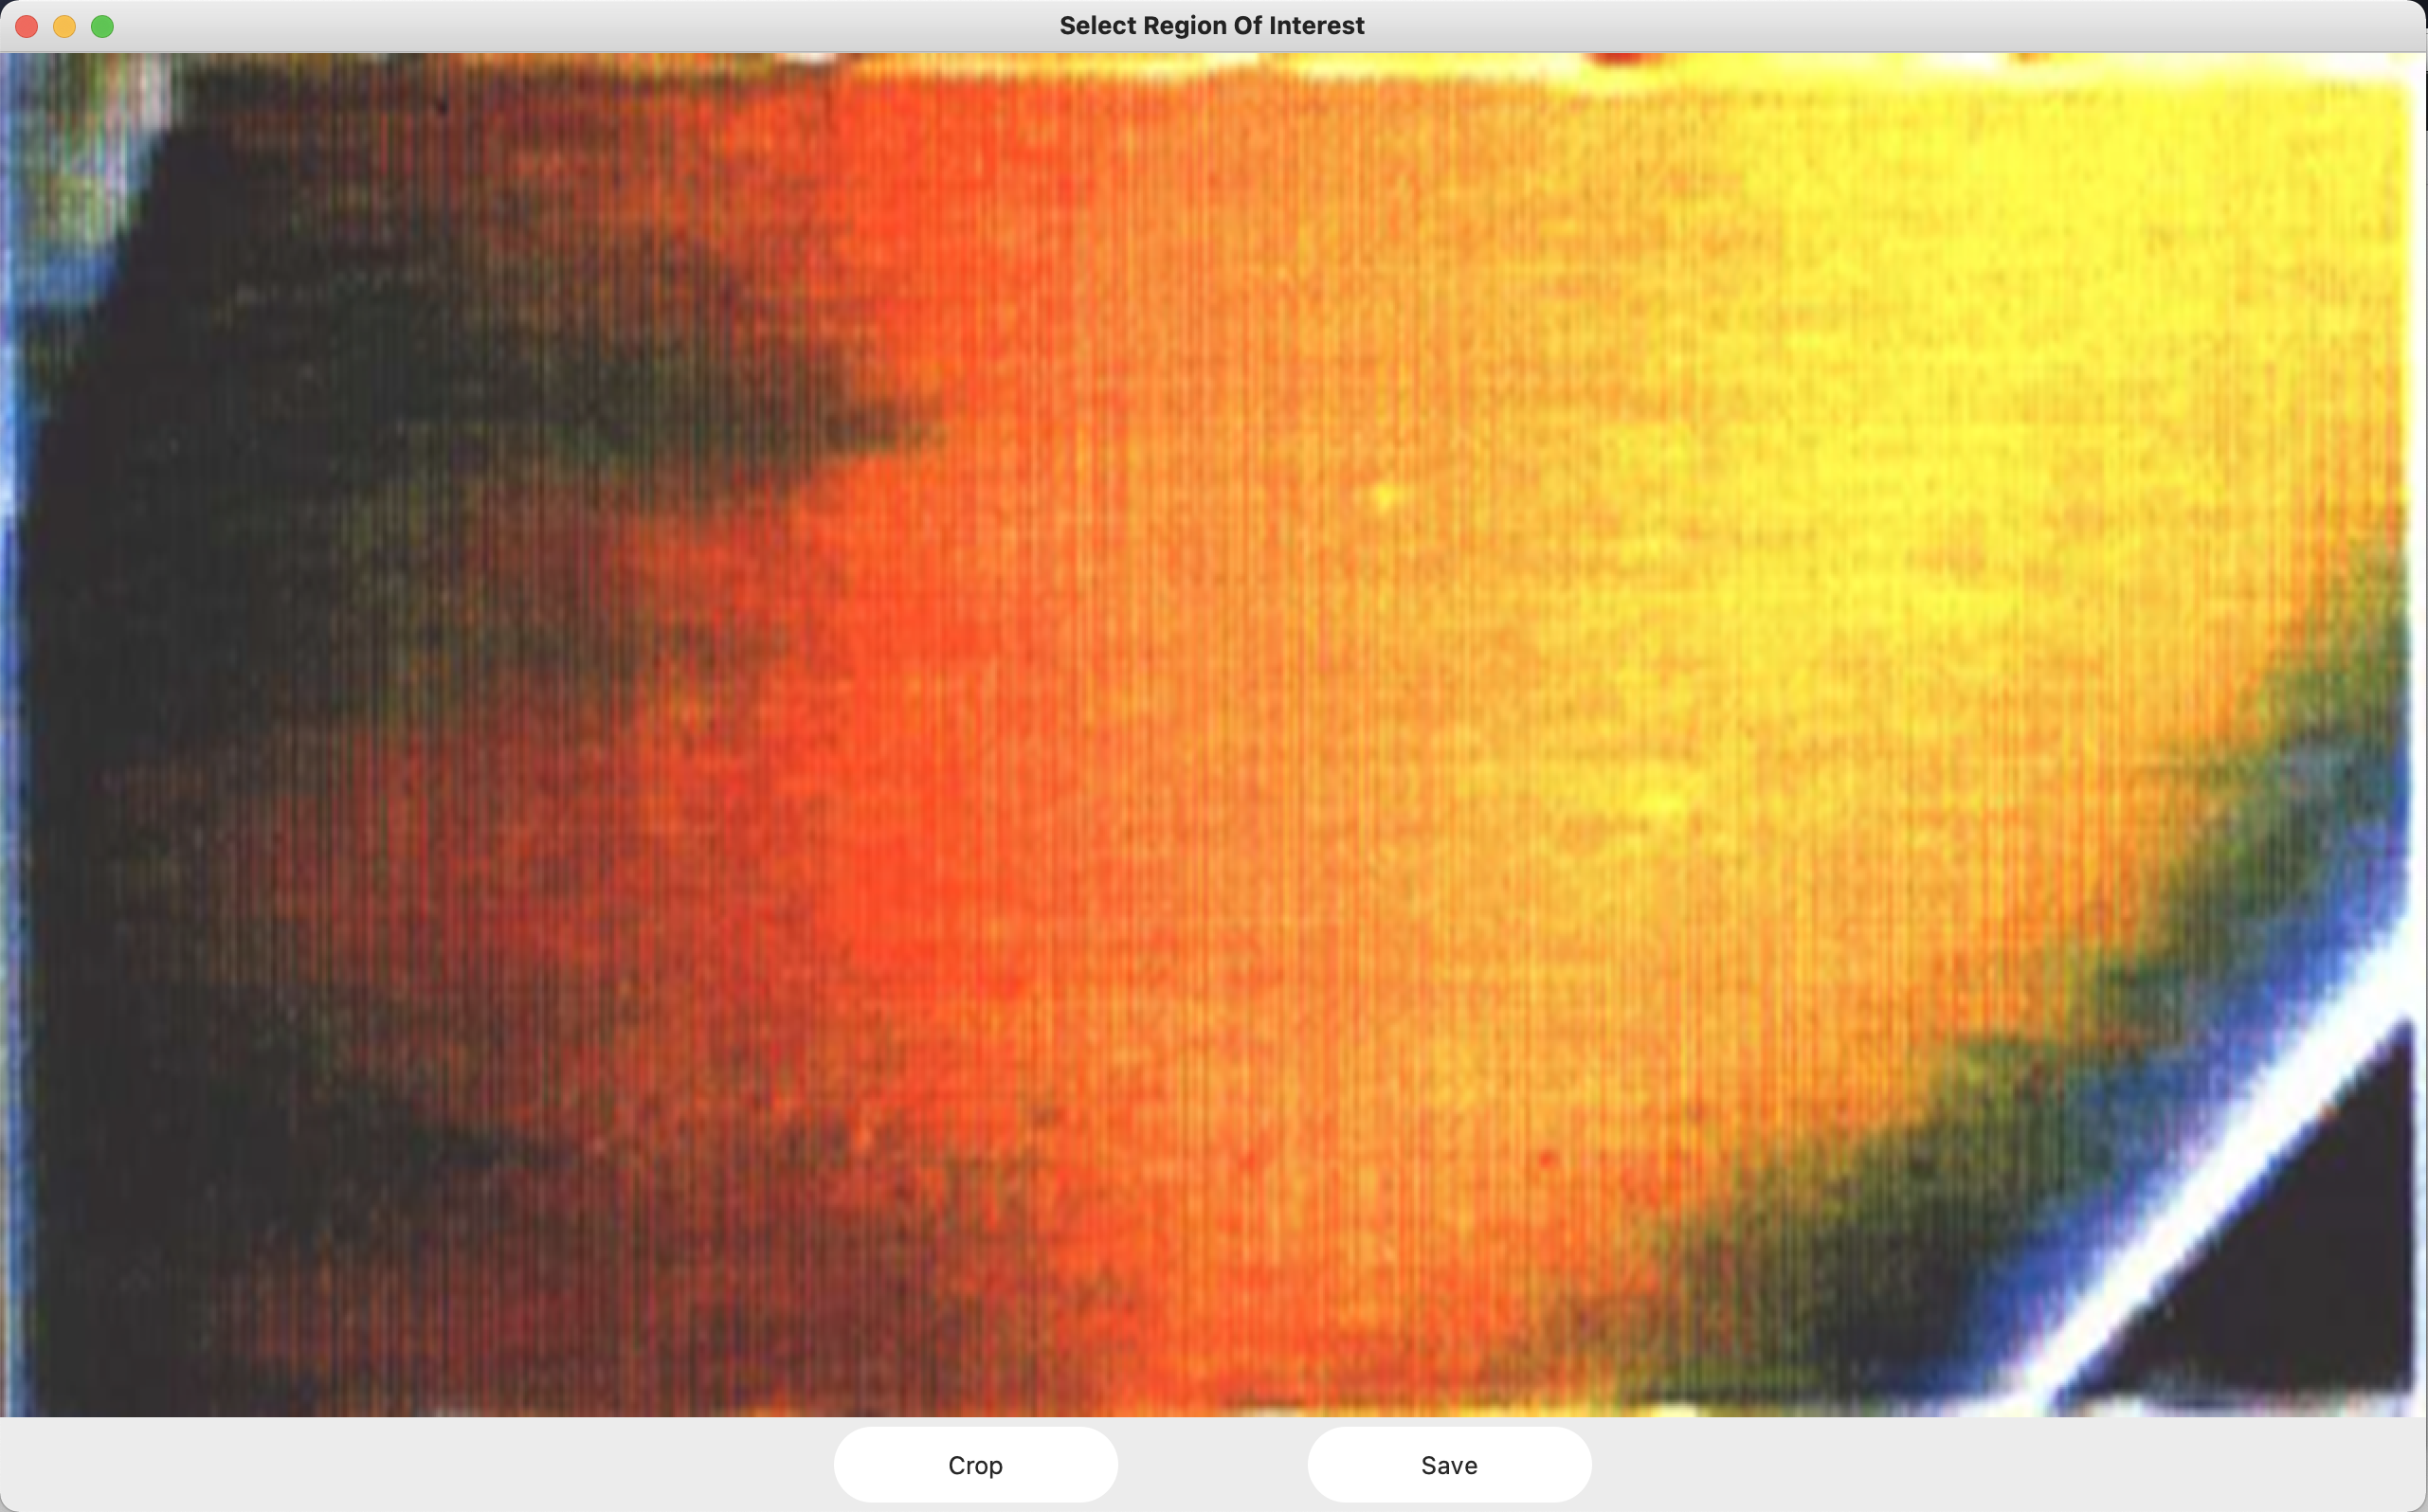Fig 3. New window to select ROI

1. The image region (ROI) on which the contour plot needs to be generated can be chosen in this window. This is done by pressing the left mouse button and dragging a rectangle inside the image and positioning the rectangle region to which the image needs to be cropped as shown in fig 4.

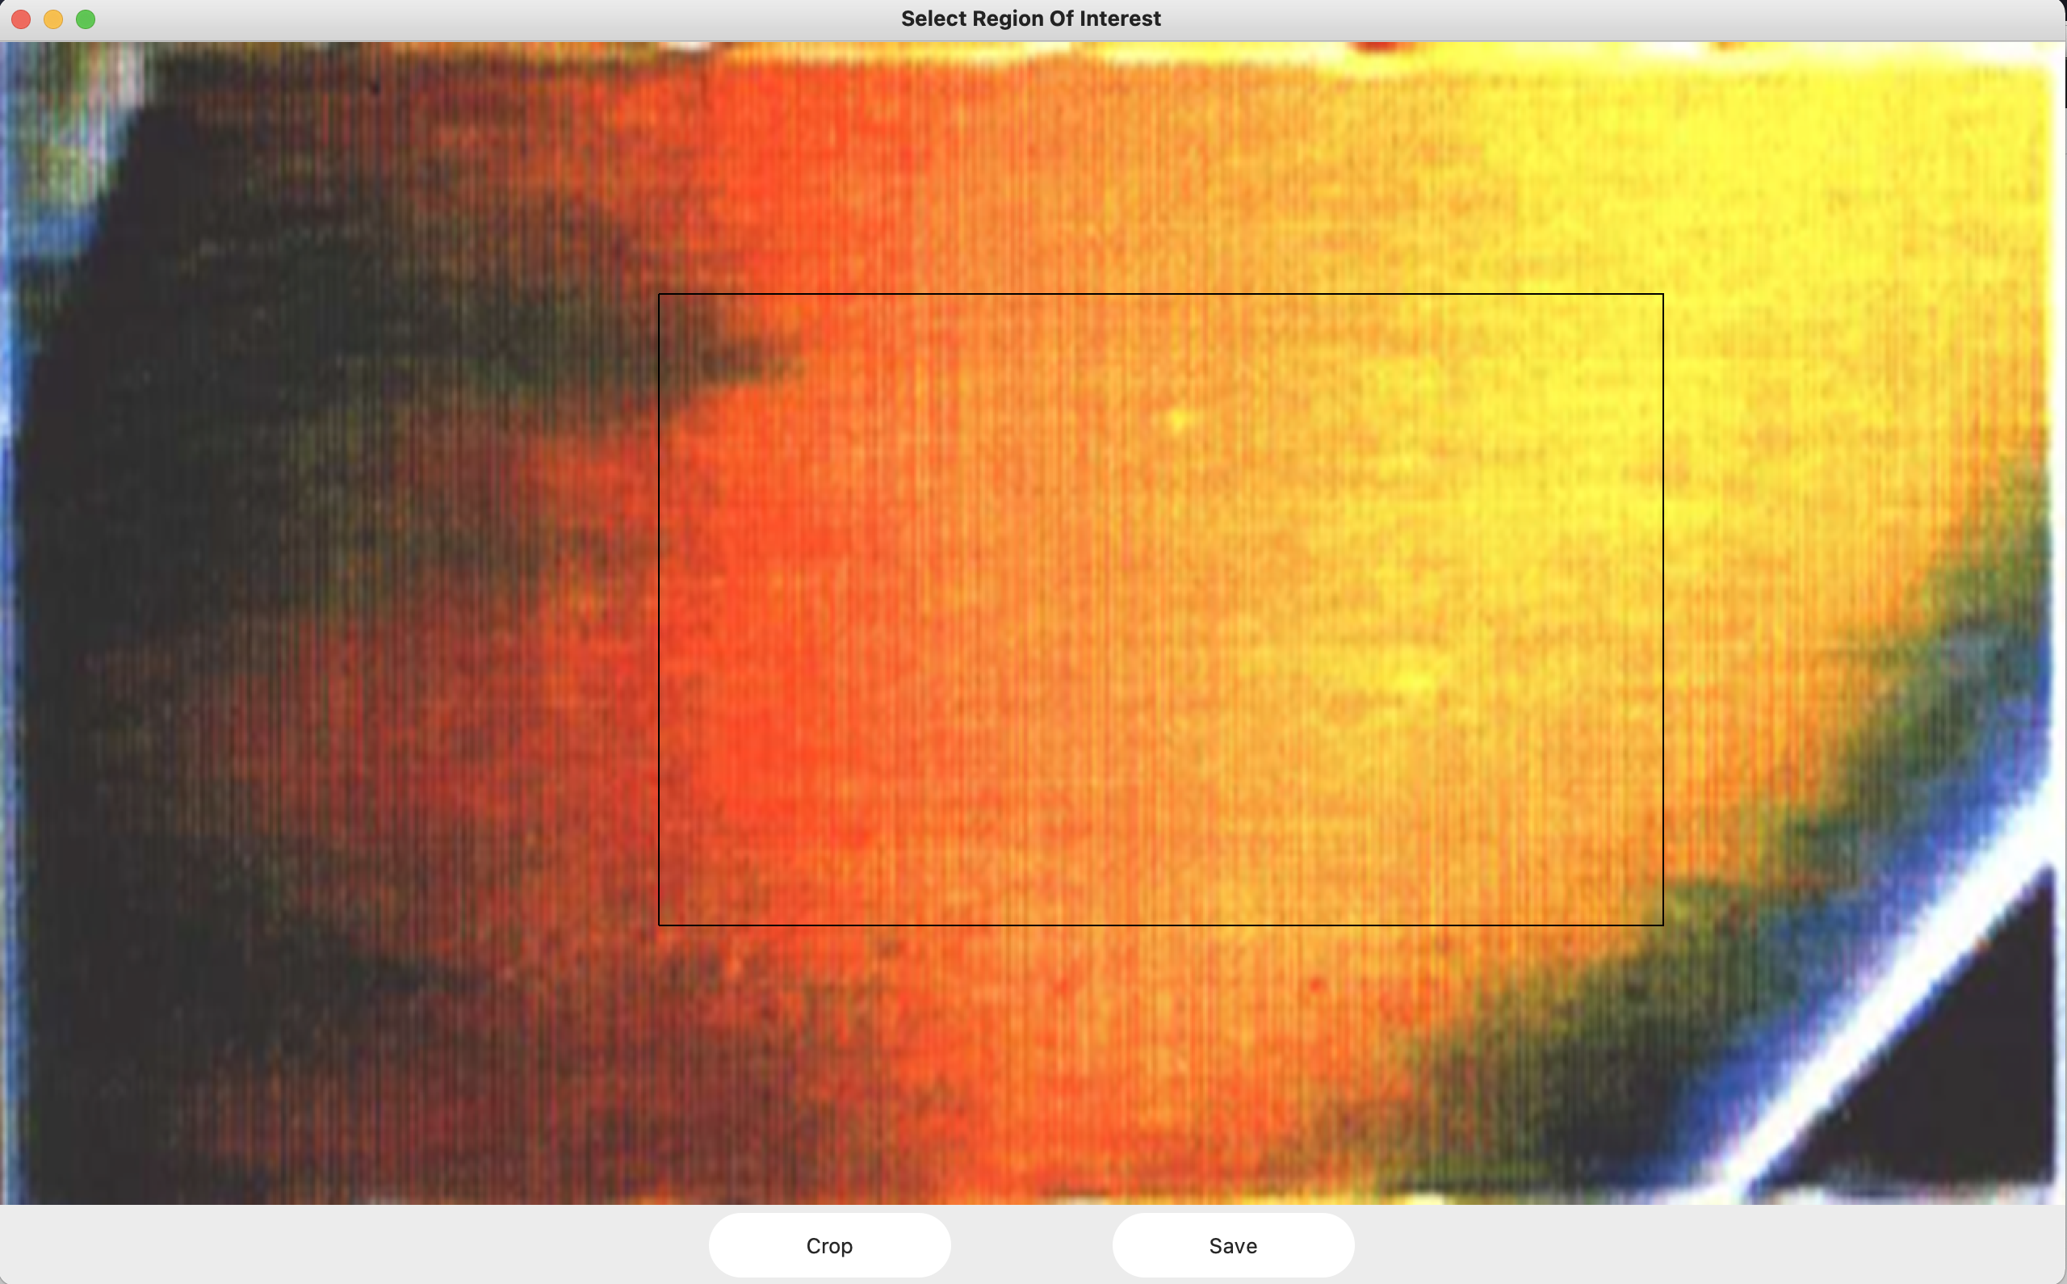Fig 4. Selecting rectangular ROI using mouse click and drag

1. The rectangle crop region can be reset by click on the image again and a new crop region can be selected.
2. Once the crop button is pressed, the image ROI is saved.
3. This image ROI is then used to generate the contour once the save button is pressed.

**Procedure running in the backend :**

1. A gaussian blur of the selected size (pixels x pixels) is applied in order to remove the high frequency noise from the image.
2. The image is then processed as default RGB or converted to HSV based on the user selected option for the contour plot.
3. The image is 3-channel in both the formats and the channels are split into individual arrays.
4. Once the individual channels are obtained (R, G, B or H, S, V), the channels are normalized by dividing each pixel value by the maximum allowed value in OpenCV.
5. For example let us say that the user chose the option for Red contour to be plotted. The Normalized Red array is calculated for the every pixel in the image and the maximum and the minimum values are obtained.
6. The values are then split into the required number of intervals (e.g. 4 in our case) and the contours in the image are detected for these values in the intervals.
7. The pixel coordinates of each contour is stored in an array to be used for final contour plot.
8. There are basically two types of contours – Open & Closed. Open contours do not close in on themselves, and they end in any one of the boundary edges of the image. Closed contours on the other hand have the same start and end points meaning they form a closed loop.
9. Once the contours are detected, the contour properties like the area (no. of pixels inclosed by contour), centroid (for closed contours) and the end points of open contours are stored in respective arrays.
10. In case of the closed contours, in order to avoid numerous small blobs of closed contours in the final processed image, we set a threshold value for the minimum area (no. of pixels) required to be enclosed by the contour. If the contour is smaller than this threshold then it is not plotted in the final contour image. This is shown in fig. 5 where the first image has a lot more number of small closed contours when compared to the second one because of the smaller criteria for threshold area. The value of this threshold can be chosen in the GUI.

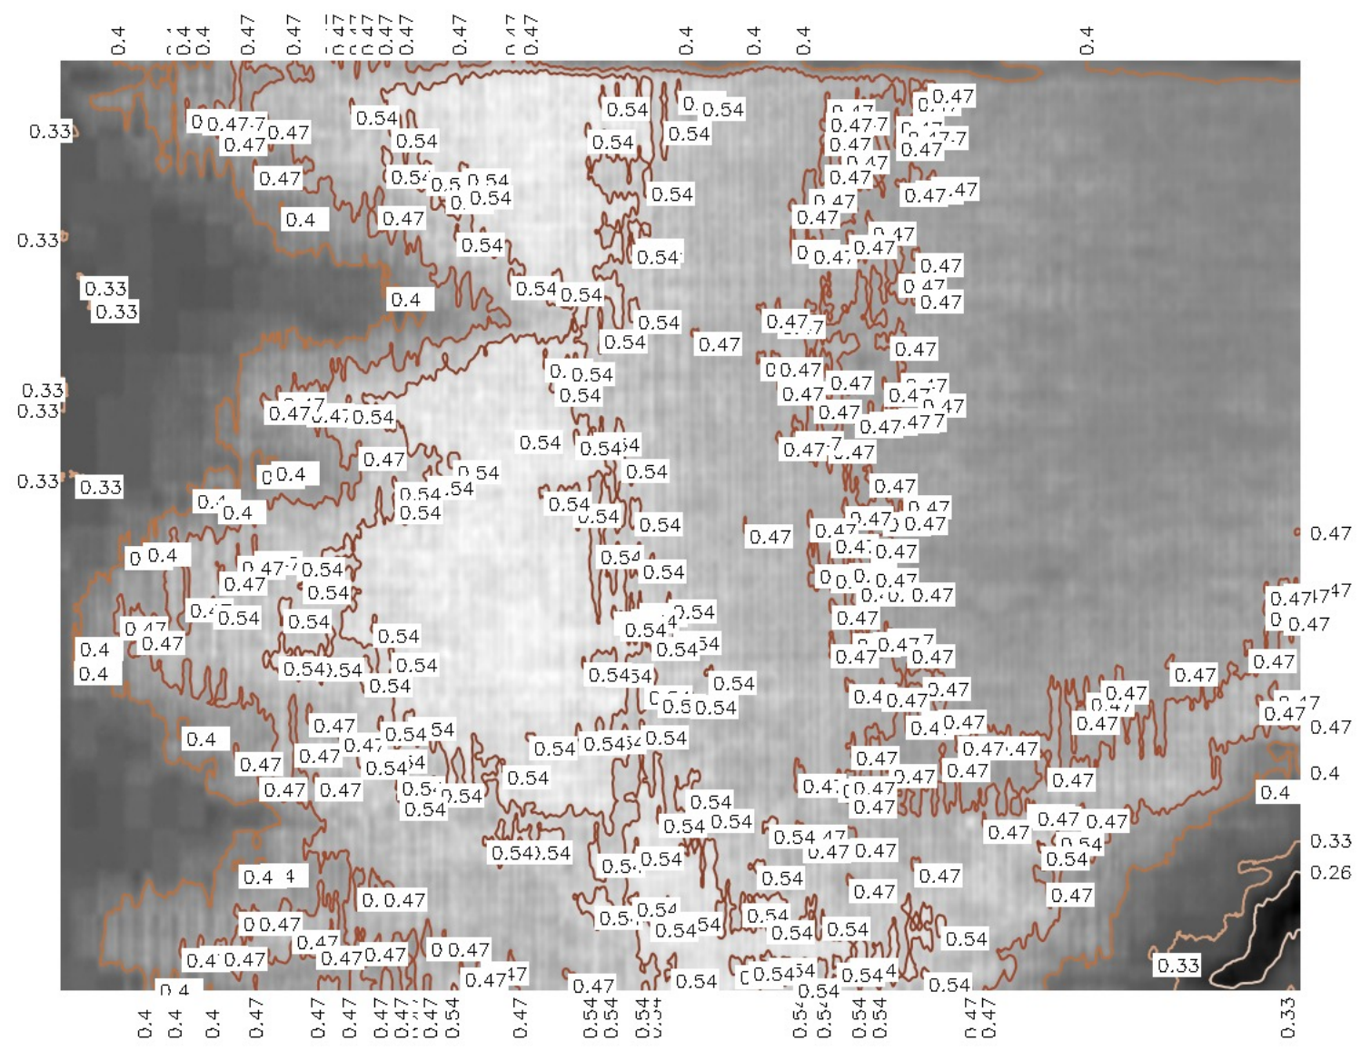

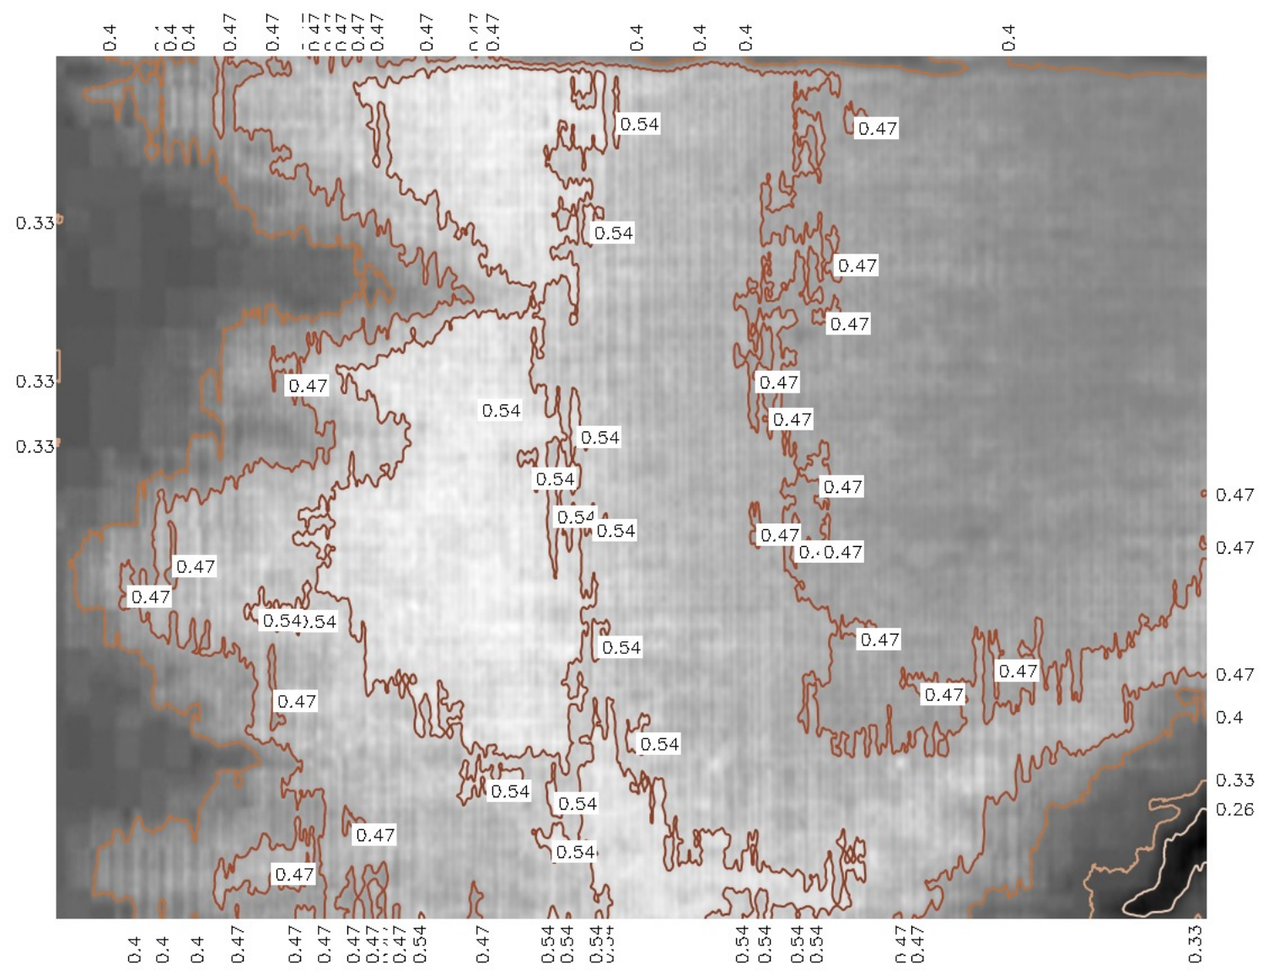

Fig 5. Contours generated with different closed contour area thresholds.

1. The next step is generating the labels for the contour values that need to be placed next to the contour in the final image. The labels of the contours are generated for every value for which the contour was generated.
2. The contours are plotted on to a grayscale image, and the value labels are added next to the contours edges (in case of open contours) and at the centroid (in case of closed contours).
3. Once the processing of the final contour plot is completed, it is saved as an image in the same format as that of the input image as shown in the fig 6 below.

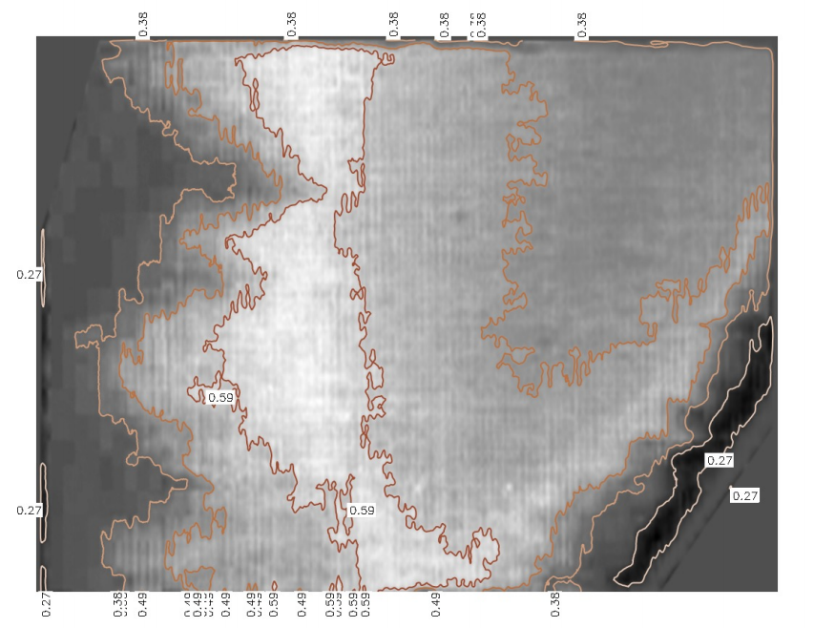Fig 6. Final Contour lines for red generated over the grayscale image